**PG-DAC AUGUST 24 BATCH**

1)Write a Java program that takes a list of integers as input and returns a list of duplicate integers.

Program code:

package org.collection.question1;

import java.util.ArrayList;

import java.util.HashSet;

import java.util.List;

import java.util.Scanner;

import java.util.Set;

public class DublicateIntegers {

public static List<Integer>findDublictes(List<Integer> numbers){

Set<Integer> S = new HashSet<>();

List<Integer> dublicates = new ArrayList<>();

for(Integer num : numbers) {

if(!S.add(num)) {

dublicates.add(num);

}

}

return dublicates;

}

public static void main(String[] args) {

Scanner sc = new Scanner(System.in);

System.out.println("Enter Integers:");

String[] input = sc.nextLine().split(" ");

List<Integer> numbers = new ArrayList<>();

for(String s : input) {

numbers.add(Integer.parseInt(s));

}

List<Integer>dublicates = findDublictes(numbers);

System.out.println("Dublicates: " + dublicates);

sc.close();

}

}

Output:

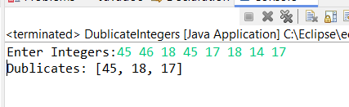

2)Create a Person class with attributes name and age. Write a Java program that sorts a list of Person objects first by age and then by name if the ages are equal.

Program code:

package org.collection.question2;

import java.util.ArrayList;

import java.util.Collections;

import java.util.Comparator;

import java.util.List;

public class Person {

private String name;

private int age;

public Person(String name, int age) {

this.name = name;

this.age = age;

}

public String getName() {

return name;

}

public int getAge() {

return age;

}

@Override

public String toString() {

return name + " " + age ;

}

static class AgeComparator implements Comparator<Person> {

public int compare(Person p1, Person p2) {

int ageComparison = p1.getAge() - p2.getAge();

if (ageComparison == 0) {

return p1.getName().compareTo(p2.getName());

}

return ageComparison;

}

}

public static void main(String[] args) {

List<Person> per = new ArrayList<>();

per.add(new Person("Rahul", 24));

per.add(new Person("Siddh", 20));

per.add(new Person("Rohit", 24));

per.add(new Person("Balu", 22));

Collections.sort(per, new AgeComparator());

System.out.println("Sorted list by age, then name: ");

for (Person person : per) {

System.out.println(person.getName() + " " + person.getAge());

}

}

}

Output:

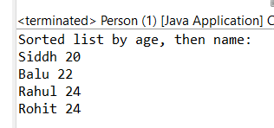

3)Write a Java program to find the first non-repeated character in a string using a HashMap.

String input = "aabbccddeffg";

Expected output = 'e';

Program code:

**package** org.collection.question3;

**import** java.util.HashMap;

**public** **class** FirstNonRepeatedCharacter {

**public** **static** **char** findFirstNonRepeatedChar(String input) {

HashMap<Character, Integer> charCount = **new** HashMap<>();

**for** (**char** ch : input.toCharArray()) {

charCount.put(ch, charCount.getOrDefault(ch, 0) + 1);

}

**for** (**char** ch : input.toCharArray()) {

**if** (charCount.get(ch) == 1) {

**return** ch;

}

}

**return** '0';

}

**public** **static** **void** main(String[] args) {

String input = "aabbccddeffg";

**char** result = *findFirstNonRepeatedChar*(input);

**if** (result != '0') {

System.***out***.println("First non-repeated character: " + result);

} **else** {

System.***out***.println("No non-repeated character found.");

}

}

}

Output:

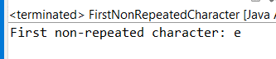

4) Write a Java program that merges two sorted lists of integers into a single sorted list.

Program code:

**package** org.collection.Question4;

**import** java.util.ArrayList;

**import** java.util.Collections;

**import** java.util.List;

**public** **class** MergeSortedList {

**public** **static** List<Integer> mergeSortedList(List<Integer> list1, List<Integer>list2){

List<Integer> mergedlist = **new** ArrayList<>(list1);

mergedlist.addAll(list2);

Collections.*sort*(mergedlist);

**return** mergedlist;

}

**public** **static** **void** main(String[] args) {

List<Integer> list1 = **new** ArrayList<>();

list1.add(10);

list1.add(30);

list1.add(50);

list1.add(70);

List<Integer> list2 = **new** ArrayList<>();

list2.add(20);

list2.add(40);

list2.add(60);

list2.add(80);

List<Integer> mergedList = *mergeSortedList*(list1, list2);

System.***out***.println("Merged Sorted List: " + mergedList);

}

}

Output:

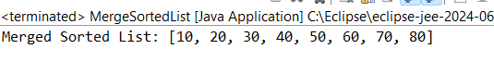s